Tabish Parkar

Formative Assessment 1: Praxis S2

HPXS200-1

1. Player

Attributes - Name, Date of Birth, Contact Information, Medical History, Position, Performance Statistics

Identifier - Player ID

Coaching Staff

Attributes - Coach Name, Contact Details, Coaching Certifications, Coaching History, Teams/Age Groups

Identifier - Staff ID

Training Session

Attributes - Date, Time, Location, Session Type (Drills, Scrimmage, Fitness)

Identifier - Session ID

Match

Attributes - Opponent, Date, Location, Outcome, Goals Scored, Goals Conceded

Identifier - Match ID

Facility

Attributes - Facility Name, Location, Field Type (Grass or Turf), Seating Capacity, Maintenance Schedule

Identifier - Facility ID

2.

Player -

* A player must have a unique Player ID.
* Players must provide accurate contact information for communication purposes.
* Medical history must be regularly updated for player safety.

Coaching Staff -

* Each coach must be assigned to specific teams or age groups.
* Coaching certifications must be valid and up to date.
* Contact details of coaching staff should be readily accessible.

Training Session -

* Each session must have a unique Session ID.
* Training sessions should be scheduled in advance and communicated to players.
* Session details must be recorded accurately for performance analysis.

Match-

* Each match should have a unique Match ID.
* Match outcomes and goal statistics must be recorded for performance evaluation.
* Opponent details should be documented for match preparation.

Facility -

* Each facility must have a unique Facility ID.
* Maintenance schedules should be followed to ensure optimal facility conditions.
* Field type and seating capacity information should be accurate for planning purposes.

3.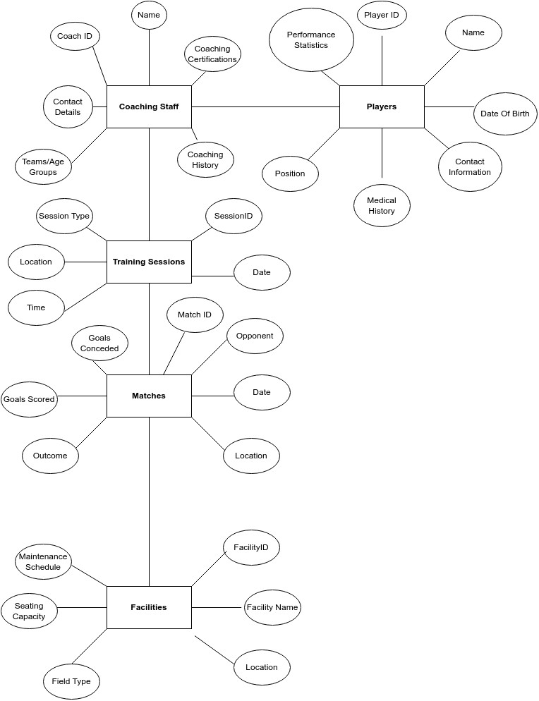

4.

Coaches -

* Coaches can access player profiles, schedule training sessions, record match outcomes, and analyse performance data to enhance coaching strategies.

Players –

* Players can view their profiles, check training schedules, track match results, and monitor their performance statistics for self-improvement.

Parents –

* Parents can stay informed about their child's progress, upcoming training sessions, match outcomes, and facility information through the database.

Administrators –

* Administrators can manage player/coach profiles, schedule training sessions and matches, oversee facility maintenance, and generate reports for overall academy performance assessment.